**COGNIZANT DIGI NURTURE 4.0**

**WEEK 6 MANDATORY HANDS ON BY (6377625)**

**REACT:**

File name: 1. ReactJS-HOL

**Program:**

* After the installation of the node, In vscode terminal or command prompt create a react app using the following command

npx create-react-app myfirstreactapp

* In vscode open the myfirstreactapp folder and modify the app.js.

**App.js:**

function App() {

  return (

    <div>

      <h1>Welcome to the first session of React</h1>

    </div>

  );

}

export default App;

* **Type “npm start “ in terminal**

**OUTPUT:**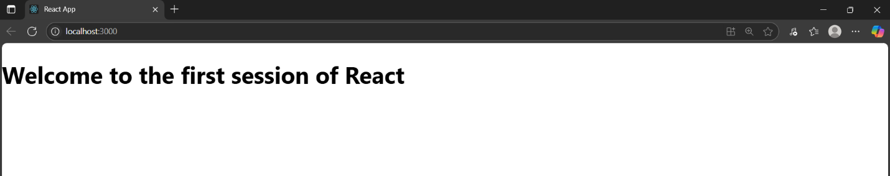

File name: 2. ReactJS-HOL

**Program:**

* In vscode terminal or command prompt create a react app using the following command

npx create-react-app studentapp

* In vscode open the studentapp folder and create a new folder in src/Components
* Inside the Components create Home.js

**Home.js:**

import React from 'react';

class Home extends React.Component {

render() {

return (

<div>

<h2>Welcome to the Home page of Student Management Portal</h2>

</div>

);

}

}

export default Home;

* Inside the Components create About.js

**About.js:**

import React from 'react';

class About extends React.Component {

render() {

return (

<div>

<h2>Welcome to the About page of the Student Management Portal</h2>

</div>

);

}

}

export default About;

* Inside the Components create Contact.js

**Contact.js:**

import React from 'react';

class Contact extends React.Component {

render() {

return (

<div>

<h2>Welcome to the Contact page of the Student Management Portal</h2>

</div>

);

}

}

export default Contact;

* In src/App.js write the following commands.

**App.js:**

import React from 'react';

import './App.css';

import Home from './Components/Home';

import About from './Components/About';

import Contact from './Components/Contact';

function App() {

return (

<div className="App">

<Home />

<About />

<Contact />

</div>

);

}

export default App;

* Type “npm start” in Terminal

**OUPUT:**

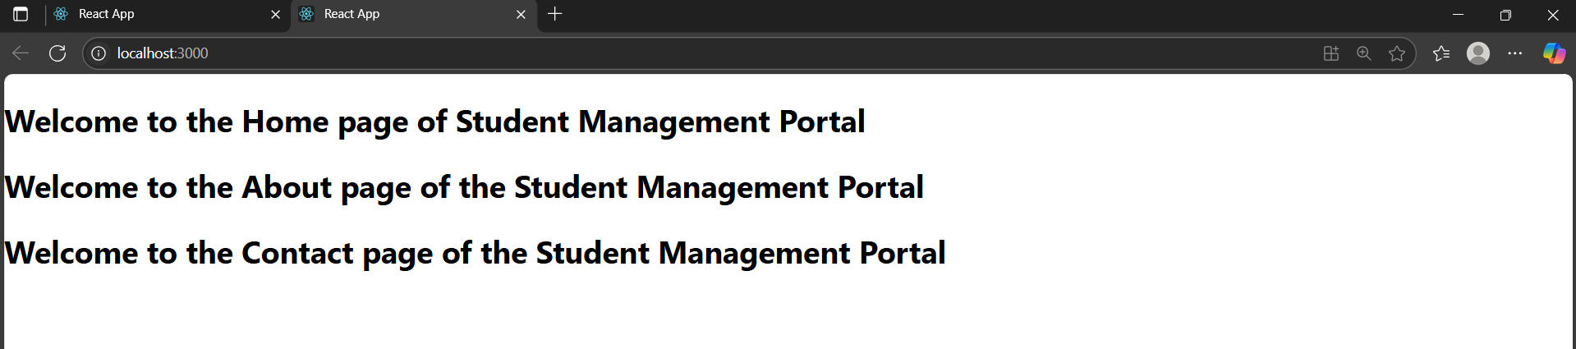

File name: 3. ReactJS-HOL

**Program:**

* Create a scorecalculatorapp in react using npx create-react-app scorecalculatorapp in terminal or cmd. Then open the folder in vs code and create Components and Stylesheets folder in src.
* In the Components folder create a file named

CalculateScore.js

**CalculateScore.js**

import React from 'react';

import '../Stylesheets/mystyle.css';

function CalculateScore(props) {

  const { name, school, total, goal } = props;

  const average = total / goal;

  return (

    <div className="score-card">

        <center>

      <h2 className="score-title">Student Details</h2>

      <p className="name"><strong>Name:</strong> {name}</p>

      <p className="school"><strong>School:</strong> {school}</p>

      <p className="total"><strong>Total Marks:</strong> {total}</p>

      <p className="average-score"><strong>Score:</strong> {average.toFixed(2)}</p>

    </center>

    </div>

  );

}

export default CalculateScore;

* In stylesheets folder create mystyle.css

**Mystyle.css**

 .score-card {

  background-color: #f9f9f9;

  padding: 20px;

  margin: 30px auto;

  width: 60%;

  border-radius: 8px;

  box-shadow: 0 0 10px rgba(0, 0, 0, 0.1);

  font-family: Arial, sans-serif;

}

.score-title {

  color: brown;

  font-size: 24px;

  margin-bottom: 15px;

}

.name {

  color: blue;

}

.school {

  color: red;

}

.total {

  color: rgb(98, 11, 98);

}

.average-score {

  color: green;

  font-weight: bold;

  font-size: 18px;

  margin-top: 10px;

}

**App.js**

import React from 'react';

import CalculateScore from './Components/CalculateScore';

function App() {

  return (

    <div className="App">

      <CalculateScore

        name="Steeve"

        school="DNV Public School"

        total={284}

        goal={3}

      />

    </div>

  );

}

export default App;

**OUTPUT:** 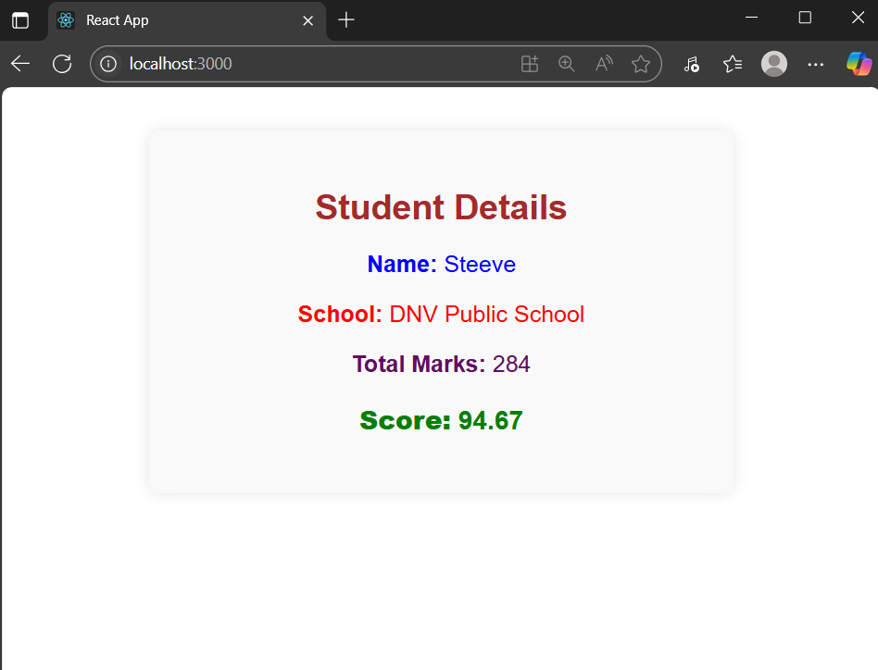

File name:4.ReactJS-HOL

**Program:**

* open vs code terminal or cmd and create blogapp in react using the following command npx create-react-app blogapp
* open the folder in vscode and create a post.js,posts.js in src folder .

**post.js:**

import React from 'react';

class Post extends React.Component {

render() {

return (

<div style={{ margin: '10px', padding: '15px', border: '1px solid #ccc' }}>

<h3>{this.props.title}</h3>

<p>{this.props.body}</p>

</div>

);

}

}

export default Post;

**posts.js:**

import React from 'react';

import Post from './Post';

class Posts extends React.Component {

constructor(props) {

super(props);

this.state = {

posts: [],

hasError: false

};

}

loadPosts = () => {

fetch('https://jsonplaceholder.typicode.com/posts')

.then(response => response.json())

.then(data => this.setState({ posts: data.slice(0, 10) })) // limit to 10 posts

.catch(error => {

console.error("Fetch error:", error);

this.setState({ hasError: true });

});

};

componentDidMount() {

this.loadPosts();

}

componentDidCatch(error, info) {

alert("An error occurred while loading posts.");

console.error(error, info);

this.setState({ hasError: true });

}

render() {

if (this.state.hasError) {

return <h2>Something went wrong.</h2>;

}

return (

<div>

<h2>Blog Posts</h2>

{this.state.posts.map(post => (

<Post key={post.id} title={post.title} body={post.body} />

))}

</div>

);

}

}

export default Posts;

* modify the src/App.js

**App.js:**

import React from 'react';

import './App.css';

import Posts from './Posts';

function App() {

return (

<div className="App">

<Posts />

</div>

);

}

export default App;

* run the npm start command in the terminal

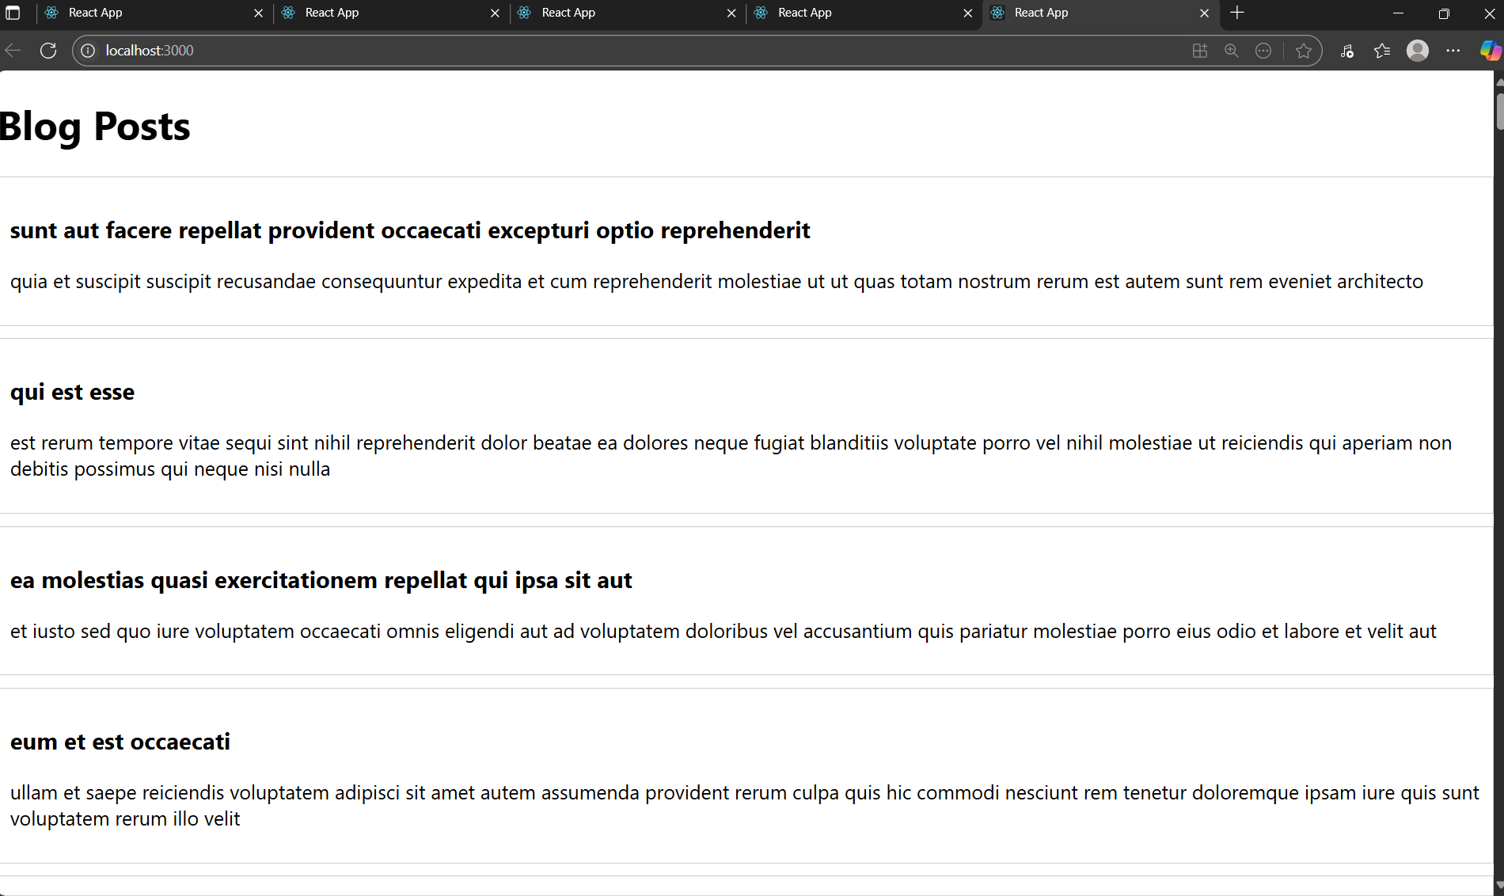**OUTPUT:**

File name: 5.ReactJS-HOL

**Program:**

* Create a react app named cohortdashboard using the following command

npx create-react-app cohortdashboard

* Create Cohortdetails.js and CohortDetails.module.css in the src folder.

**CohortDetails.js:**

import React from 'react';

import styles from './CohortDetails.module.css';

function CohortDetails({ name, status, startDate, endDate }) {

const headingStyle = {

color: status === 'ongoing' ? 'green' : 'blue',

};

return (

<div className={styles.box}>

<h3 style={headingStyle}>{name}</h3>

<dl>

<dt>Status:</dt>

<dd>{status}</dd>

<dt>Start Date:</dt>

<dd>{startDate}</dd>

<dt>End Date:</dt>

<dd>{endDate}</dd>

</dl>

</div>

);

}

export default CohortDetails;

**CohortDetails.module.css:**

.box {

width: 300px;

display: inline-block;

margin: 10px;

padding: 10px 20px;

border: 1px solid black;

border-radius: 10px;

}

dt {

font-weight: 500;

}

* Modify the App.js in the src folder.

**App.js:**

import React from 'react';

import './App.css';

import CohortDetails from './CohortDetails';

function App() {

const cohortList = [

{

name: 'Java Full Stack',

status: 'ongoing',

startDate: '2024-07-01',

endDate: '2024-12-01'

},

{

name: 'React Bootcamp',

status: 'completed',

startDate: '2024-01-15',

endDate: '2024-06-15'

}

];

return (

<div className="App">

{cohortList.map((cohort, index) => (

<CohortDetails

key={index}

name={cohort.name}

status={cohort.status}

startDate={cohort.startDate}

endDate={cohort.endDate}

/>

))}

</div>

);

}

export default App;

* Run the npm start command in terminal

**Output:**

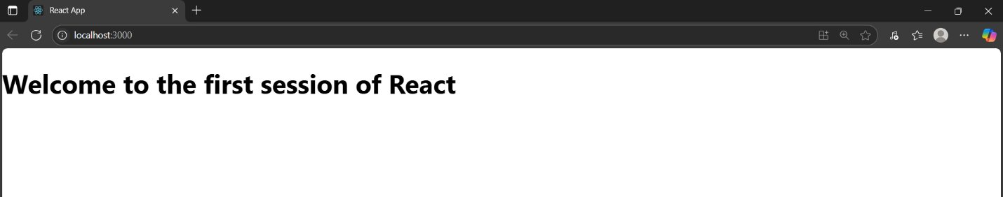

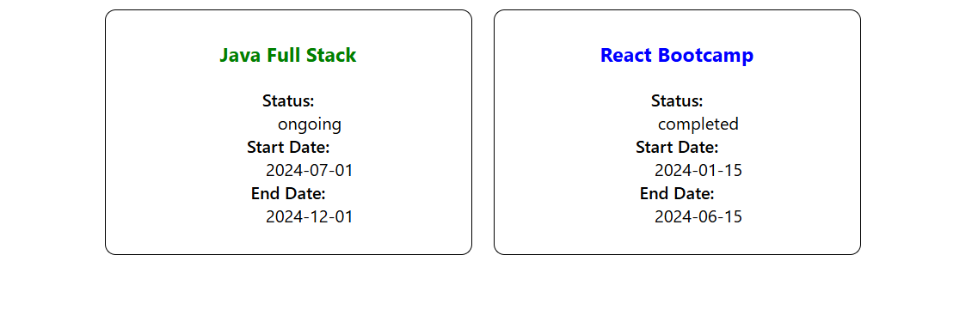

File name: 6.ReactJS-HOL

**Program:**

* Create react app named trainersapp using the following command

npx create-react-app trainersapp

* Then run cd trainersapp in terminal the run the npm install react-router-dom ,open folder in vs code.
* Create trainer.js, TrainersMock.js, Home.js, TrainerList.js, TrainerDetails.js in the in the src folder.

**trainer.js:**

class Trainer {

  constructor(trainerId, name, email, phone, technology, skills) {

    this.trainerId = trainerId;

    this.name = name;

    this.email = email;

    this.phone = phone;

    this.technology = technology;

    this.skills = skills;

  }

}

export default Trainer;

* Create components folder in src add the following files

**Home.js**

import React from 'react';

function Home() {

  return (

    <div>

      <h2>Welcome to Trainers Portal</h2>

      <p>This is the home page for managing trainers</p>

    </div>

  );

}

export default Home;

**TrainerDetails.js**

import React from 'react';

import { useParams } from 'react-router-dom';

import TrainersMock from '../data/TrainersMock';

function TrainerDetails() {

  const { id } = useParams();

  const trainer = TrainersMock.find(t => t.trainerId === parseInt(id));

  if (!trainer) return <p>Trainer not found.</p>;

  return (

    <div>

      <h2>Trainer Details</h2>

      <p><strong>ID:</strong> {trainer.trainerId}</p>

      <p><strong>Name:</strong> {trainer.name}</p>

      <p><strong>Email:</strong> {trainer.email}</p>

      <p><strong>Phone:</strong> {trainer.phone}</p>

      <p><strong>Technology:</strong> {trainer.technology}</p>

      <p><strong>Skills:</strong> {trainer.skills}</p>

    </div>

  );

}

export default TrainerDetails;

**TrainersList.js**

import React from 'react';

import { Link } from 'react-router-dom';

function TrainersList({ trainers }) {

  return (

    <div>

      <h2>Trainers List</h2>

      <ul>

        {trainers.map(trainer => (

          <li key={trainer.trainerId}>

            <Link to={`/trainer/${trainer.trainerId}`}>{trainer.name}</Link>

          </li>

        ))}

      </ul>

    </div>

  );

}

export default TrainersList;

**TrainersMock.js:**

import Trainer from '../models/Trainer';

const TrainersMock = [

  new Trainer(1, "John Doe", "john@example.com", "9876543210", "React", "Hooks, Redux, JSX"),

  new Trainer(2, "Jane Smith", "jane@example.com", "8765432109", "Angular", "Components, Services"),

  new Trainer(3, "Mike Johnson", "mike@example.com", "7654321098", "Vue", "Vuex, Lifecycle Hooks")

];

export default TrainersMock;

**App.js**

import React from 'react';

import { BrowserRouter, Routes, Route, Link } from 'react-router-dom';

import Home from './components/Home';

import TrainersList from './components/TrainersList';

import TrainerDetails from './components/TrainerDetails';

import TrainersMock from './data/TrainersMock';

function App() {

  return (

    <BrowserRouter>

      <div style={{ padding: '20px' }}>

        <nav>

          <Link to="/">Home</Link> | <Link to="/trainers">Trainers</Link>

        </nav>

        <Routes>

          <Route path="/" element={<Home />} />

          <Route path="/trainers" element={<TrainersList trainers={TrainersMock} />} />

          <Route path="/trainer/:id" element={<TrainerDetails />} />

        </Routes>

      </div>

    </BrowserRouter>

  );

}

export default App;

**OUTPUT:**

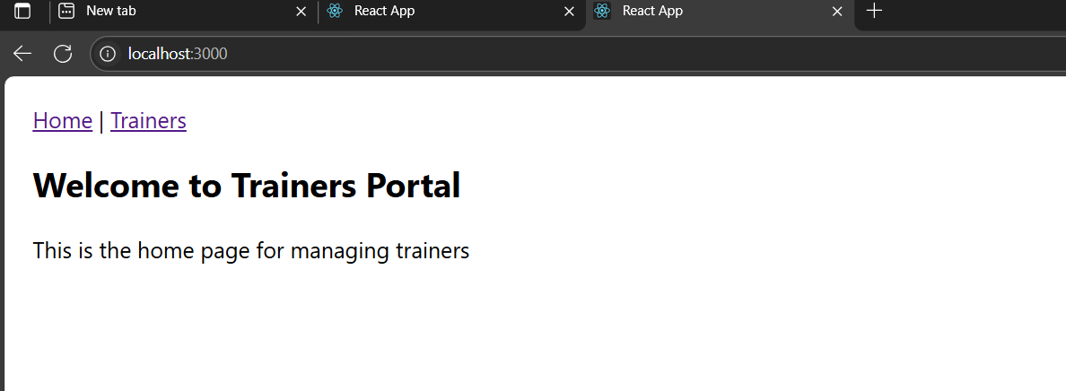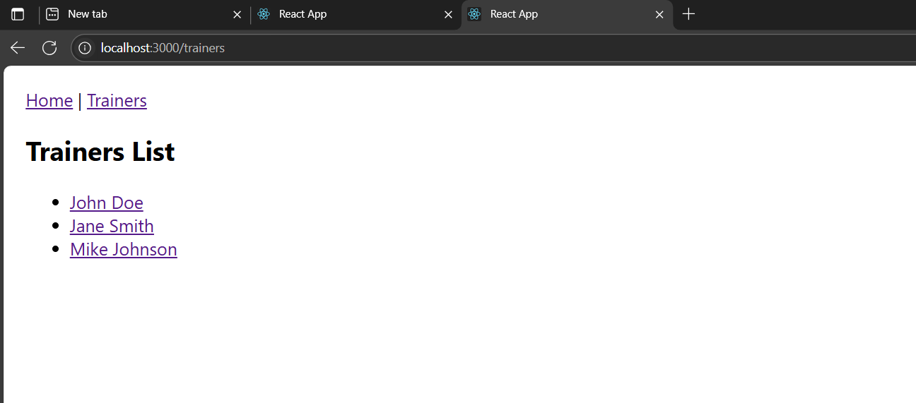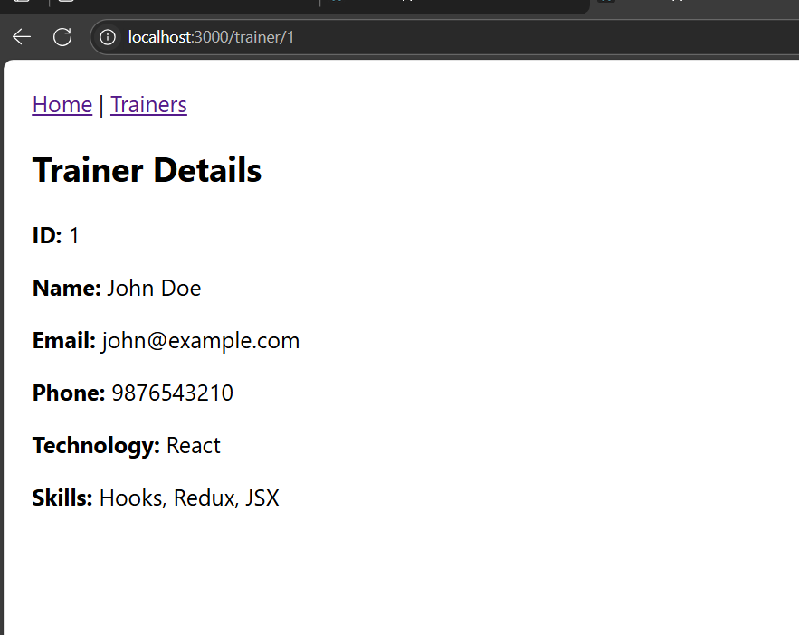

File name: 7.ReactJS-HOL

**Program:**

* Create a react app using the command

npx create-react-app shoppingapp

* Create Cart.js,OnlineShopping.js in the src folder.

**Cart.js:**

import React from 'react';

class Cart extends React.Component {

  render() {

    return (

      <tr>

        <td>{this.props.itemname}</td>

        <td>₹{this.props.price}</td>

      </tr>

    );

  }

}

Cart.defaultProps = {

  itemname: "Unknown Item",

  price: "0"

};

export default Cart;

**OnlineShopping.js:**

import React from 'react';

import Cart from './Cart';

class OnlineShopping extends React.Component {

  constructor(props) {

    super(props);

    this.items = [

      { itemname: 'T-Shirt', price: 500 },

      { itemname: 'Shoes', price: 1200 },

      { itemname: 'Watch', price: 2000 },

      { itemname: 'Backpack', price: 800 },

      { itemname: 'Sunglasses', price: 1500 },

    ];

  }

  render() {

    return (

      <div>

        <center>

        <h1 style={{color:'green'}}>Items Ordered</h1>

        <table  border="1" cellPadding="10"  style={{ borderCollapse: 'collapse', marginTop: '20px',color:"green" }}>

          <thead>

            <tr>

              <th>Item Name</th>

              <th>Price (₹)</th>

            </tr>

          </thead>

          <tbody>

            {this.items.map((item, index) => (

              <Cart key={index} itemname={item.itemname} price={item.price} />

            ))}

          </tbody>

        </table>

        </center>

      </div>

    );

  }

}

export default OnlineShopping;

**App.js:**

import React from 'react';

import OnlineShopping from './components/OnlineShopping';

function App() {

  return (

    <div className="App">

      <OnlineShopping />

    </div>

  );

}

export default App;

**OUTPUT:**

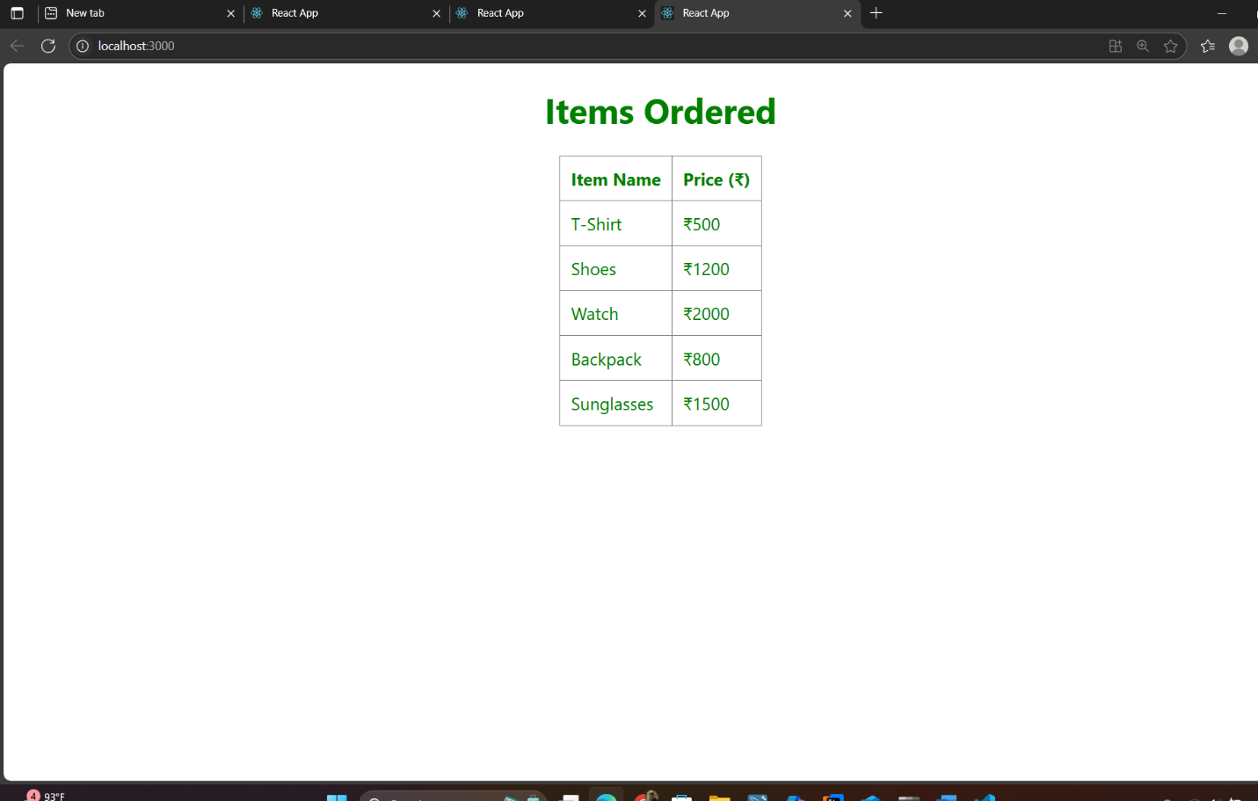

File name: 8.ReactJS-HOL

**Program:**

* Create react app named counterapp using the following command

Npx create-react-app counterapp

* Create CountPeople.js file in the src folder.

**CountPeople.js:**

import React from 'react';

class CountPeople extends React.Component {

  constructor(props) {

    super(props);

    this.state = {

      entryCount: 0,

      exitCount: 0

    };

  }

  updateEntry = () => {

    this.setState((prevState) => ({

      entryCount: prevState.entryCount + 1

    }));

  };

  updateExit = () => {

    this.setState((prevState) => ({

      exitCount: prevState.exitCount + 1

    }));

  };

  render() {

    return (

      <div style={{ display: 'flex', justifyContent: 'center', marginTop: '100px' }}>

        {/* Entry Section */}

        <div style={{ marginRight: '50px' }}>

          <button

            onClick={this.updateEntry}

            style={{

              backgroundColor: 'green',

              color: 'white',

              padding: '5px 15px',

              borderRadius: '5px',

              border: '1px solid darkgreen',

              cursor: 'pointer',

              fontWeight: 'bold'

            }}

          >

            Login

          </button>

          <span style={{ marginLeft: '10px', color: 'black' }}>

            {this.state.entryCount} People Entered!!!

          </span>

        </div>

        {/* Exit Section */}

        <div>

          <button

            onClick={this.updateExit}

            style={{

              backgroundColor: 'green',

              color: 'white',

              padding: '5px 15px',

              borderRadius: '5px',

              border: '1px solid darkgreen',

              cursor: 'pointer',

              fontWeight: 'bold'

            }}

          >

            Exit

          </button>

          <span style={{ marginLeft: '10px', color: 'black' }}>

            {this.state.exitCount} People Left!!!

          </span>

        </div>

      </div>

    );

  }

}

export default CountPeople;

**App.js**

import React from 'react';

import CountPeople from './components/CountPeople';

function App() {

  return (

    <div className="App">

      <CountPeople />

    </div>

  );

}

export default App;

**OUTPUT:**

